**PROJECT PROPOSAL  
PHARMACY MANAGEMENT SYSTEM**

# **INTRODUCTION**

Pharmacy Management System is based on a concept of taking medicine orders with payments.

The user can use the features of it which include taking new medicine order, deleting, modifying medicine orders, printing the receipt of payment and viewing the summary of total sales within a day. This mini project contains limited features, but the essential one.

# **BACKROUND**

Talking about Pharmacy Management System, the user can take a new medicine order. For this, the user has to provide the order number, name, date, number of medicine and select medicine. The user can delete the latest medicine order by providing the order number. In order to modify the order, he/she has to enter each and every detail. After taking orders, the payment is to be done from the receipt section. Here in the receipt section, the system asks for a receipt number. Then the system displays total receipt with medicine type, name, quantity, and total price.

# **FEATURES**

* Take medicine orders
* Delete and Modify medicine orders
* Print Receipt
* Make Payments
* Summary of Total Sales

# **LANGUAGES**

Pharmacy Management system is developed using C++ Programming Language and different variables, strings has been used for the development of it.

# **C++ features used**

We used follow features in this project

Header files

* Linked list(node)
* Loop
* OOP

Some C++ codes.

# **ADVANTAGES**

* Reduce time and money.
* Provide better service and accurate information.

# **FLOW CHART**

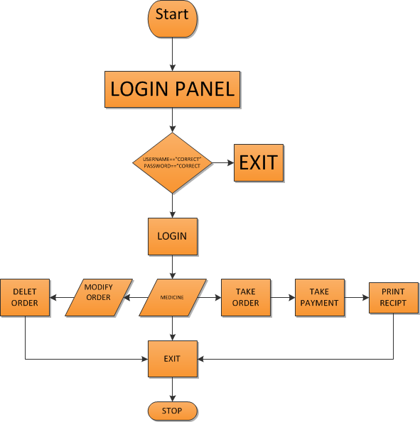

# **Code Screen Shots**

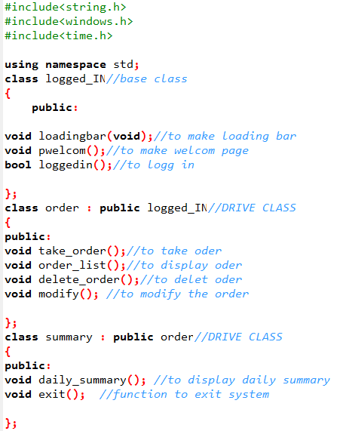

# Result

